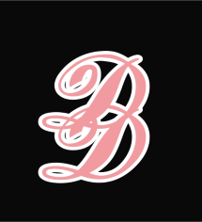
ENROLLMENT FORM
- I, the undersigned give permission for Miss Claire and her teaching staff to train my child in the arts of Tap, Ballet, Modern, Jazz, Contemporary, Musical Theatre and Acrobatic Arts. I understand that this may be done by physical contact with my child using a hands on approach to achieve the best possible outcome.
- I give Miss Claire and her teaching staff permission to administer First Aid in my absence. I am aware that the team hold up to date paediatric First Aid Certificates and I have provided a list of allergies overleaf.
- I give permission for Miss Claire and her team to document and record my childs progress within the school and I am aware Miss Claire holds the ICO certificate which is the law to be able to store Childrens information.
- I give permission for my childs image to be used for any promotional/advertising that Miss Claire deems appropriate, this could include Fliers, Wall Photographs in the dance hall and the Facebook group for parents and families of the students.
Childs names ...............................................................
Parents name print......................................................

Parents Address ...........................................................

Contact Telephone number .........................................
Contact telephone number 2 .......................................
Parents name sign ........................................................

